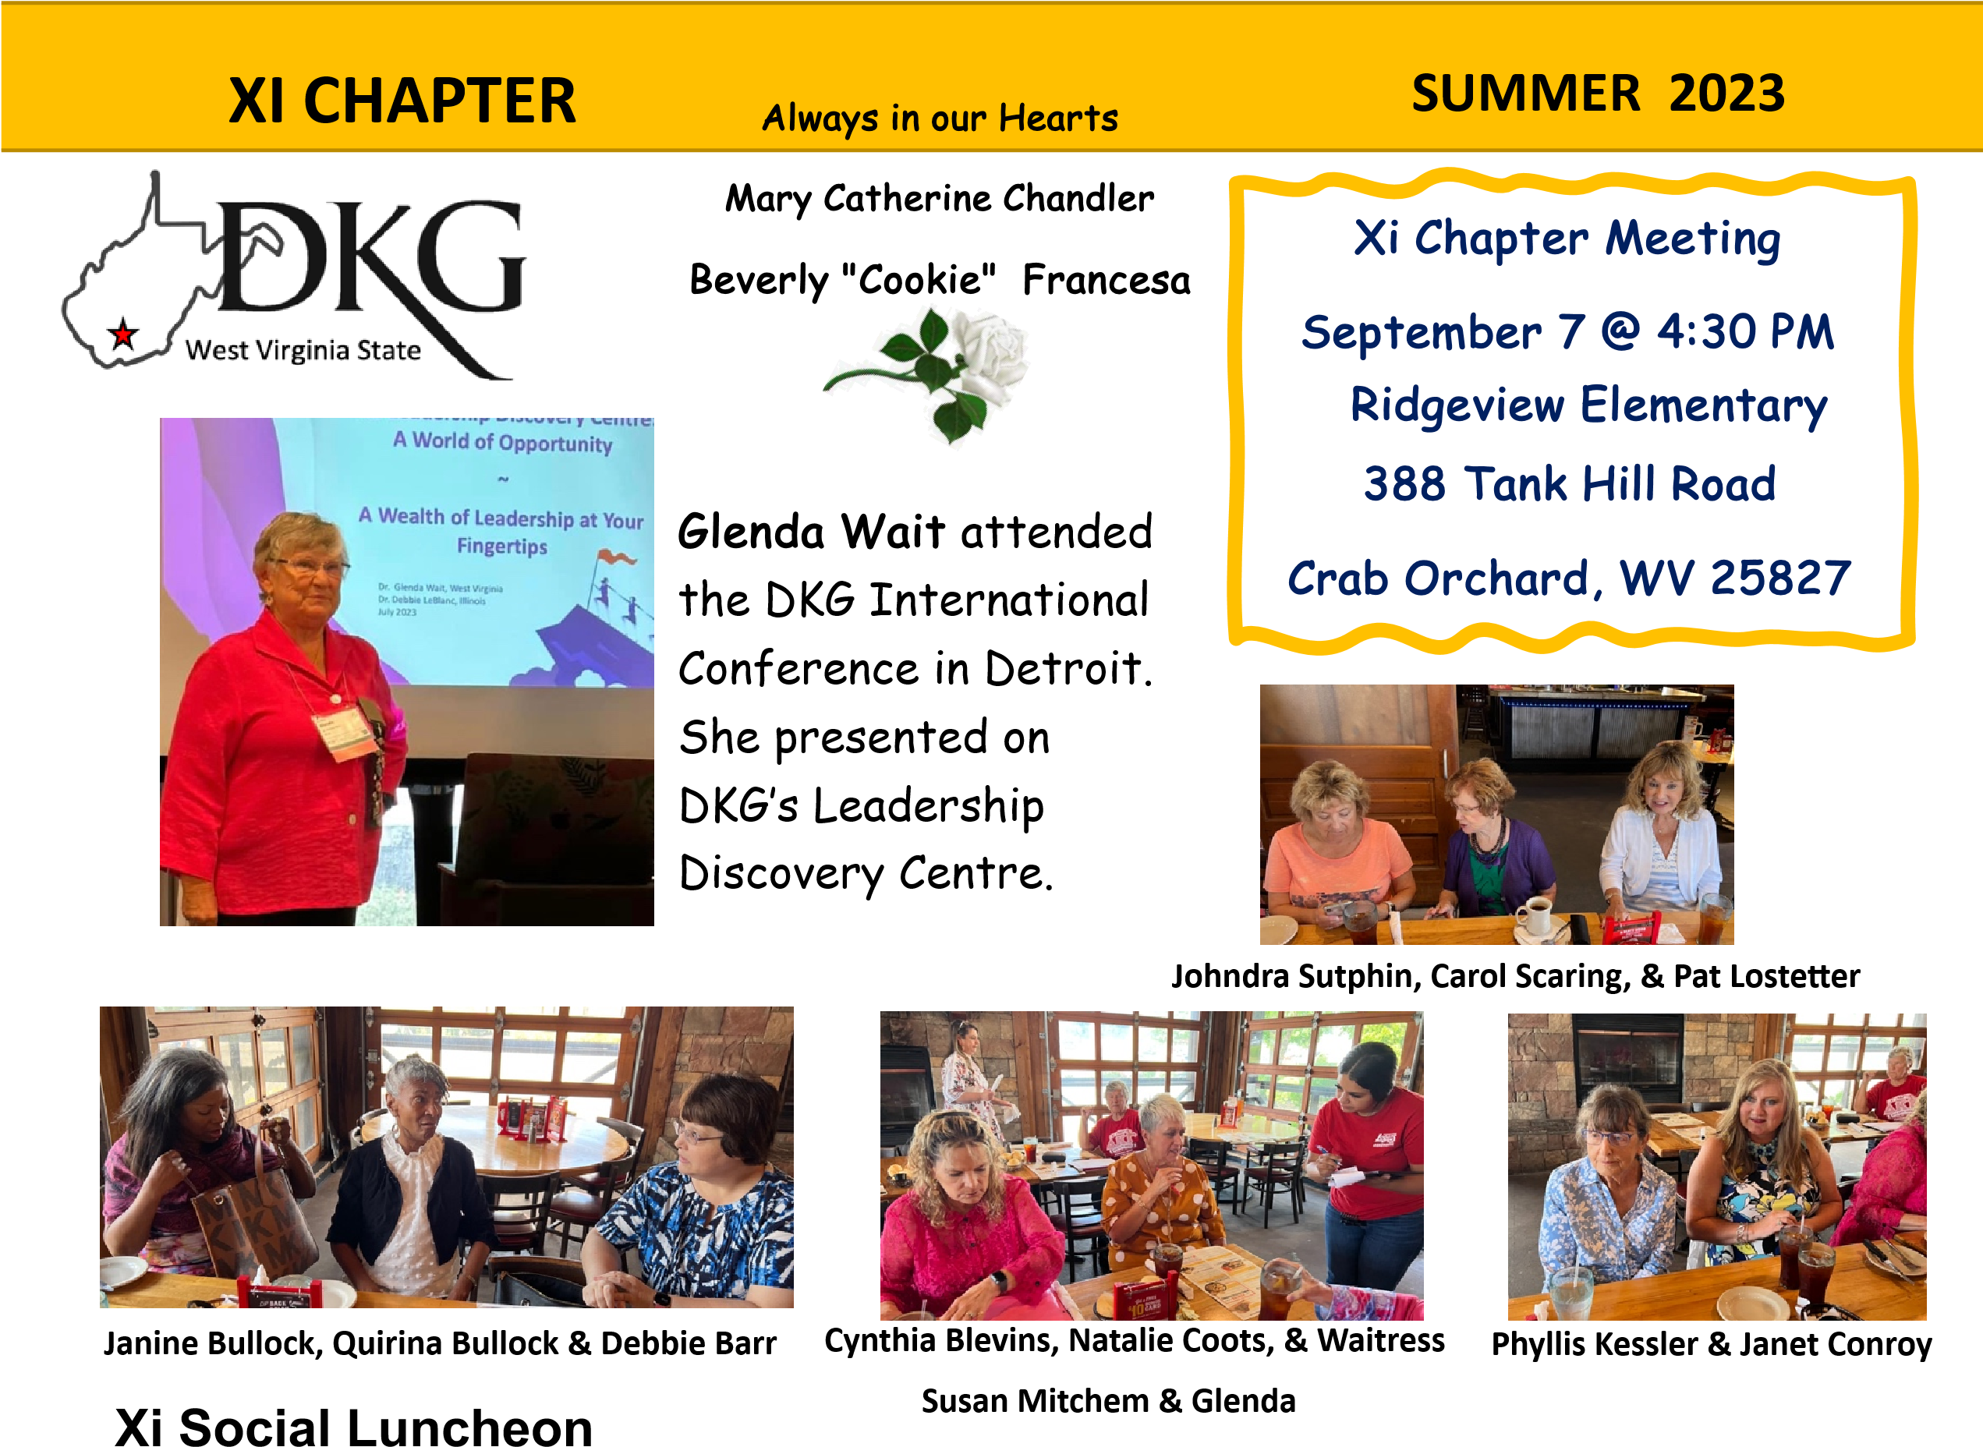
Beverly “Cookie” Francesa
Jewel Graybeal
Mary Catherine Chandler
On August 8, XI held a luncheon at Logan’s Steak House with 28 members in attendance. We discussed project and program possibilities for the up-coming year. Discussion included existing projects, potential projects, visitation and tours, suggested speakers, and programs to empower members.
Dolly Parton
Imagination Library
Linda Kutilek is proud to announce that XI Chapter donated $2,380.00 this past year to the Raleigh County Imagination Library.
October
3rd Patty Hunter, Dana Melroy
6th Janet Conroy
7th Carol Carroll
15th Claytina Shepherd
September
3rd Libby Baker
5th Grace Rinehard
9th Martha Hutchinson

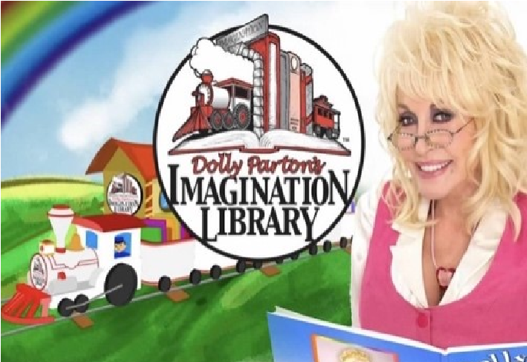
Next Meeting: October 9 – 4:30 pm
Beckley Area Foundation

